Name: MOHIT SHARMA | Signature: 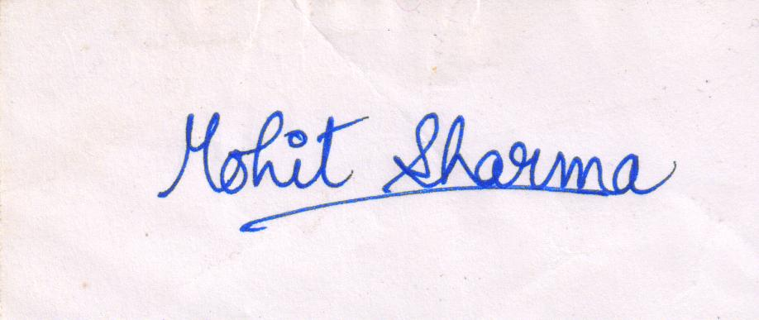
Student ID: 110031631 | Email address: sharma88@uwindsor.ca

By participating in VIP-CSL you are agreeing to the terms outlined in this contract. Due to the pandemic, most positions will be remote but there may be a few that require in-person volunteering. All workshops, activities, and meetings for VIP (outside of your volunteer placement) will take place virtually. If you apply to and are matched with a role that requires in-person activity, you will be asked to complete an additional informed consent procedure.

As a participant in the University of Windsor VIP-CSL experience, I agree to:

- Pay my administration fee and abide by the withdrawl policy communicated to me; I understand that this fee is non-refundable and that I will not be matched with a placement or allowed to participate in the experience if this fee is not paid before the deadline.
- Accept the placement assigned to me by the staff, or make alternate arrangements and find my own placement within a non-profit or publicly funded organization that has not posted a VIP-CSL position this term, subject to the approval of the coordinator.
- Create and upload an acceptable resume on mySuccess and authorize Career Development & Experiential Learning to share it with potential supervisors.
- Complete at least 40 hours of volunteer work; I will complete this by the deadline set for the term that I participate in and provide proof of the number of hours worked (signed by my supervisor) to Career Development & Experiential Learning at the end of my placement.
- Participate in all professional development workshops and reflection activities as scheduled; I understand that a component of these activities may require that I share personal information, such as the activities I was involved in at my placement, with my peers and/or member(s) of Career Development & Experiential Learning staff for purposes of skill development and/or reflection on my experiences.
- Complete and/or submit assignments and exercises as directed and on-time.
- Check the Blackboard site and my e-mail regularly and maintain contact with Career Development & Experiential Learning via email (vip@uwindsor.ca) and/or scheduling an appointment with the appropriate staff member as directed.
- Contact the VIP-CSL staff in advance to negotiate an extension or other alternative (if possible), and provide appropriate supporting documentation of medical reasons in the event of an unavoidable emergency which prevents me from meeting an assignment deadline, attending a required activity, or fulfilling the duties of my placement.
- Authorize Career Development & Experiential Learning to contact me via email and/or mailing addresses I have provided with information about additional learning and volunteer opportunities.
- Successfully complete all VIP-CSL requirements; if I choose not to, I am aware that I will not receive recognition on my official University of Windsor transcript nor will I receive a certificate of completion.
- Comply with rules and regulations outlined on this contract and deadlines outlined in the Syllabus provided; I understand that failure to do so may prevent me from completing this experience or result in my removal from this opportunity.
Placement Expectations
- Conduct myself in a professional manner at all times and do my best to ensure that I represent the University of Windsor positively.
- Arrive at my placement on time and remain for scheduled hours. I will notify my placement supervisor as early as possible in the case of illness or personal emergency during which I am unable to volunteer during previously scheduled or agreed upon hours.
- Maintain regular contact with my placement supervisor via email, telephone and/or in-person or video meetings. I will respond to email and voicemail messages in a timely manner and make arrangements in advance if it is necessary to change regularly scheduled hours or previously agreed upon days of work.
- Perform the tasks assigned by my placement supervisor to the best of my ability.
- Abide by the code of conduct, dress code, health & safety guidelines and any other policies set forth by my placement organization.
- Maintain confidentiality of the placement organization and any of its clients that I may come into contact with.
- Discuss any questions, concerns, or problems that I encounter in the performance of my duties with my placement supervisor.
- Notify the VIP-CSL staff of problems or concerns related to my participation as soon as they arise.
- Receive satisfactory or better evaluation from my supervisor on the Employer Evaluation of the Student form. I understand that if I receive a less than satisfactory rating, I will not successfully complete the experience.

